Assignment 1

**Name: ______Jack Gaskins_________**

**CSC-2592**

***COMPLETE THE HONOR CODE BELOW***

'----------------------------------------------------------------------------------

' **HONOR CODE:**

' I pledge that this program represents my own program code, I have received

‘ help from no one and I have given help to no one.

' OR

' I received help from **NAME OR NO ONE** in designing and debugging my

’ program.

' I given help to **NAME OR NO ONE** in designing and debugging my program.

'-----------------------------------------------------------------------------------

Assignment Instructions

**Failure to follow these instructions will result in a significant grade reduction.**

Please name this document XXX_ Assignment01 where XXX are your initials.

***Please see each individual JAVA problem for naming requirements.***

**The deliverables that are to be uploaded to the assignment are:**

1. This completed document with your solutions in it. Do not remove any part of this document. (PLEASE DO NOT INCLUDE THIS DOCUMENT IN THE ZIPPED FILE). This document must be completed using Microsoft Word 2016 or newer edition of Microsoft Word. A PDF file that is compatible with myLearning may also be optionally submitted. In any case, the submitted file must open in myLearning for grading. If the file does not open in myLearning I will have nothing to grade and the result will be a zero for the assignment.
2. All Java source code in a zipped file. Please name this zip file XXX_ Assignment01 where XXX are your initials.

Precisely follow the instructions in the video “Instructions for the Submission of Homework Assignments” and watch any additional videos in the modules that discuss the homework for additional instructions.

Any problem that is not done will receive a grade of zero. Please see the grading rubric for this assignment; individual problem point values are shown there.

Follow all applicable CSC-2592 Java Programming Standards for this assignment.

Include Header comments on all programs submitted. See Below:

/**

//***********************************************************************

'Project: Assignment #

'Programmer: FULL NAME

'Company Info: EMAIL

'Date: DD MM YYYY

'Description: Problem Number #.

'

' LINE 1 AT LEAST 3 LINES OF PROGRAM DESCRIPTION

' LINE 2 AT LEAST 3 LINES OF PROGRAM DESCRIPTION

' LINE 3 AT LEAST 3 LINES OF PROGRAM DESCRIPTION

'

' --------------------------------------------------------------------------

' HONOR CODE:

' I pledge that this program represents my own program code, I have received

' help from no one and I have given help to no one.

'

' OR

'

' I received help from NAME OR NO ONE in designing and debugging my program.

' I given help to NAME OR NO ONE in designing and debugging my program.

'-----------------------------------------------------------------------------

'

' LINE LENGTH - AVOID LINES LONGER THAN 80 CHARACTERS

' SCALE BELOW IS TO CALIBRATE SCREENSHOTS

' DO NOT HAVE YOUR CODE OR SCREENSHOT EXTEND BEYOND THE SCALE

0........1.........2.........3.........4.........5.........6.........7.........8

12345678901234567890123456789012345678901234567890123456789012345678901234567890

*/

PLACE SCREEN SHOT OF PROGRAM CODE and CONSOLE OUTPUT HERE.

Please note that I made the screen shot using the windows snipping tool, had the appropriate comments in the program, had the program number as it was in the assignment. In addition, all code from the program is visible and legible [with line numbers](http://www.itc.csmd.edu/tec/dickw/2591G/Video/C00/Ch00_Adding_Line_Numbers.html). In the screen shot of the console output the date and time must be shown and highlighted. If you are not familiar with the windows [snipping tool video](http://www.youtube.com/watch?v=vrRbXac71Qs) please watch it now.

Follow all applicable CSC-2592 Java Programming Standards for this assignment.

Be sure to

Have **the correct Javadoc comments** as required in the programming standards.

This you tube video is excellent and describes exactly how and why to use JAVADOC COMMENTS.

**[Play Now](http://www.youtube.com/watch?v=6XoVf4x-tag)**

**THIS IS WHAT IS EXPECTED FROM THE SCREEN SHOT:**

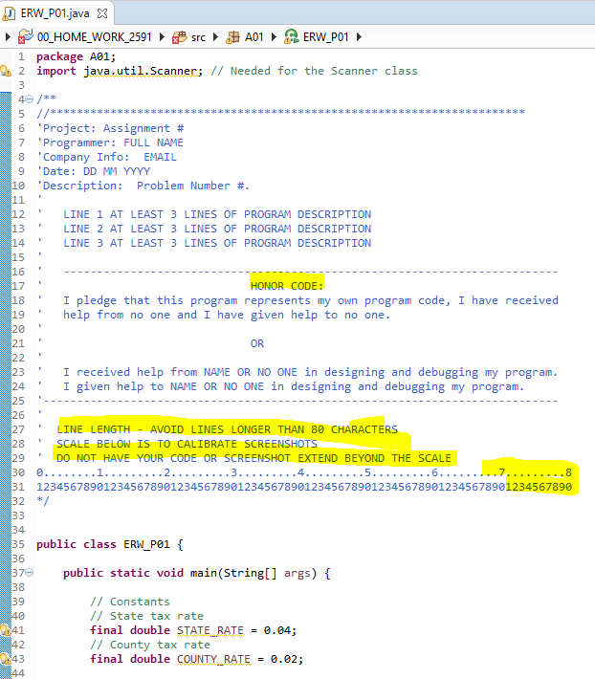

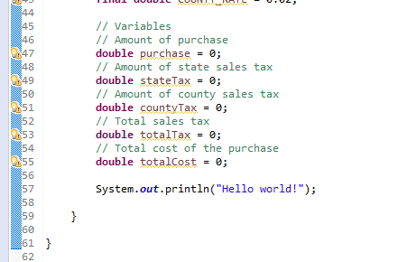

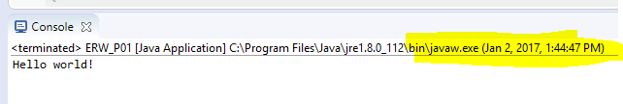

If you are using JOptionPane Show Screen shots of all messages and I/O for all cases, for example:

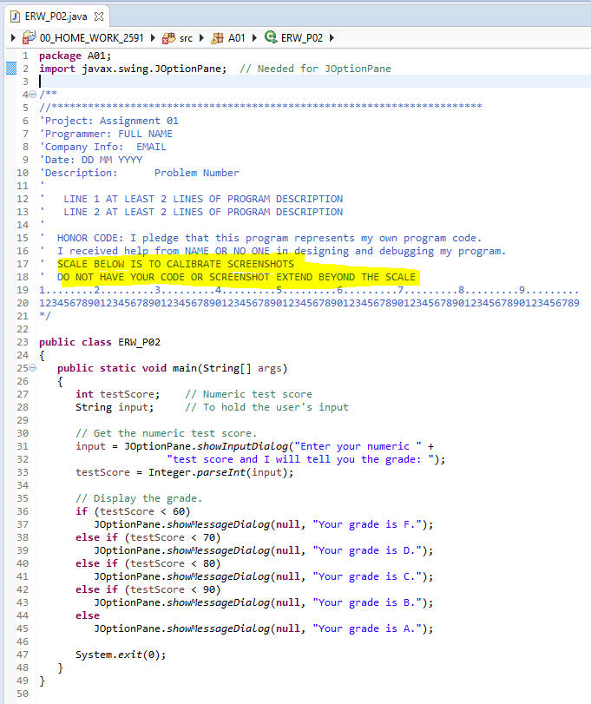

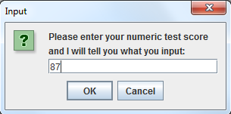

1. Please name your program XXX_P01 where XXX are your initials.

Create a JavaFX application that lets the user enter the food charge for a meal at a restaurant. When a button is clicked, the application should calculate and display the amount of an 18 percent tip on the total food charge, 7 percent sales tax, and the total of all three amounts.

PLACE SCREEN SHOT OF PROGRAM CODE AND CONSOLE PROGRAM OUTPUT HERE

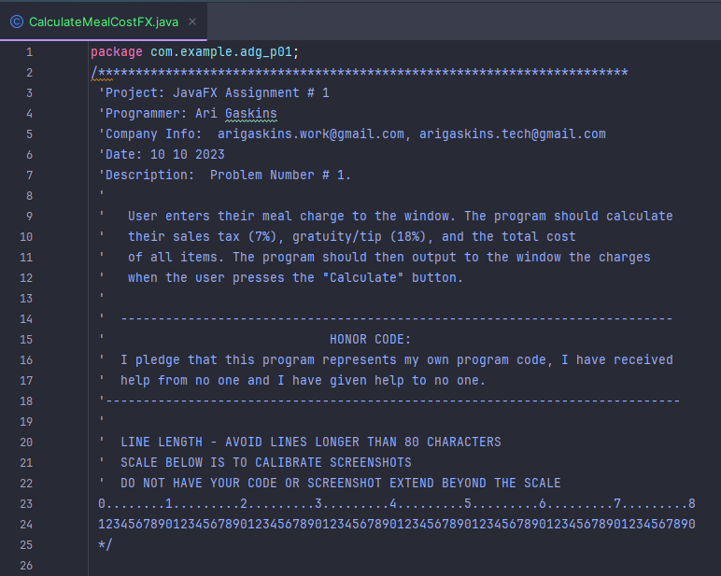

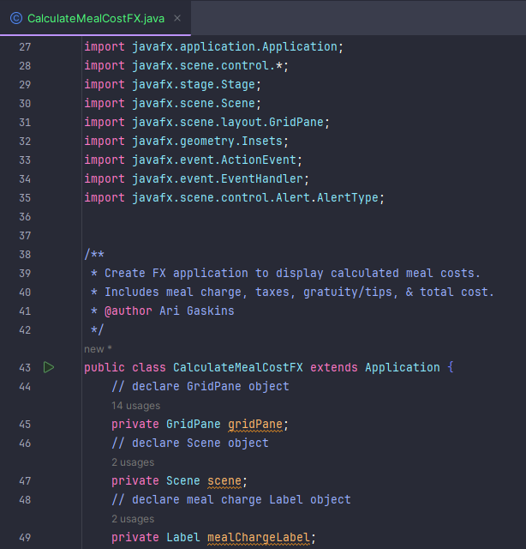

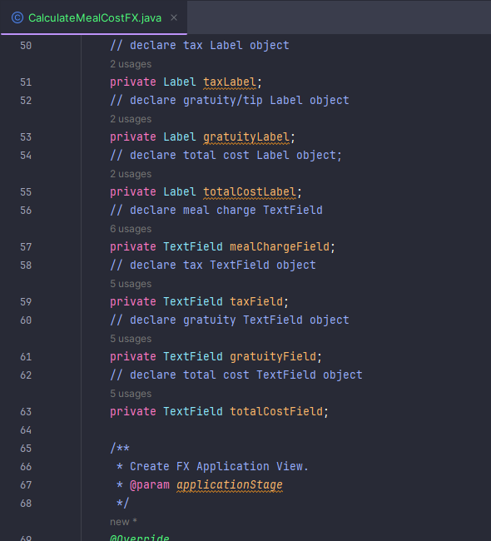

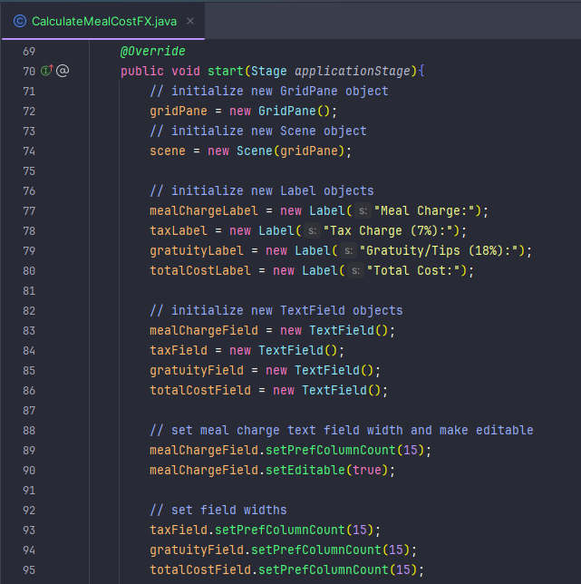

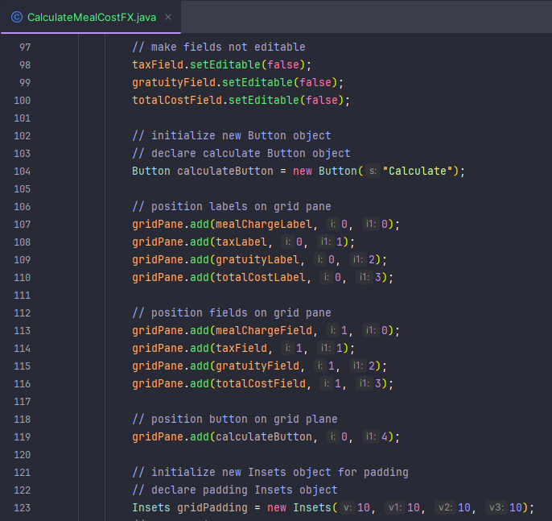

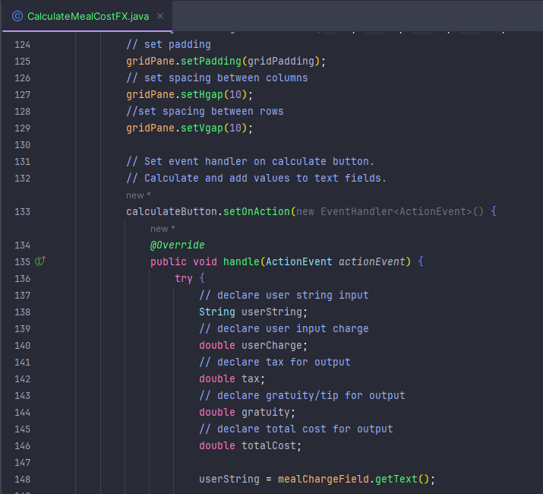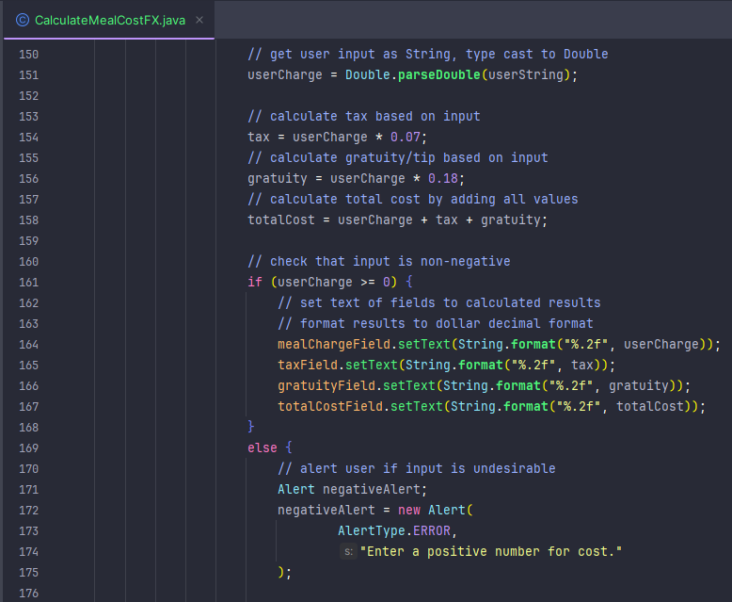

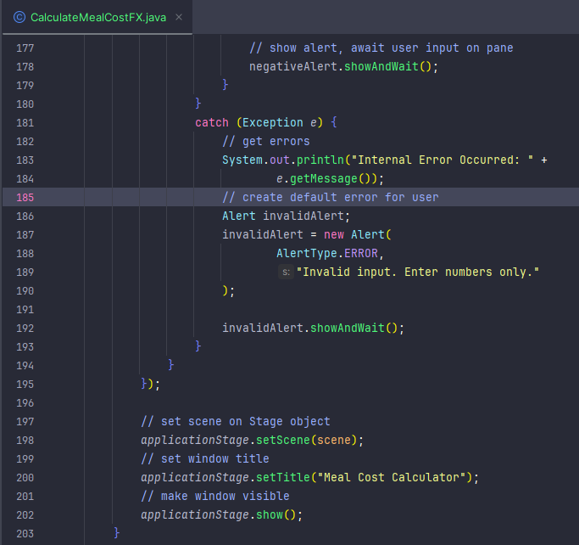\

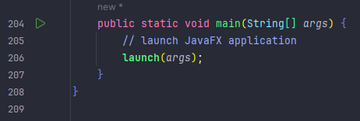

1. Please name your program XXX_P02 where XXX are your initials.

Create an application that calculates the registration fees for a conference. The general conference registration fee is $895 per person, and student registration is $495 per person. There is also an optional opening night dinner with a keynote speech for $30 per person. In addition, the optional preconference workshops listed in the table are available.

|  |  |
| --- | --- |
| **Workshop** | **Fee** |
| **Introduction** to E-commerce | $295 |
| The Future of the Web | $295 |
| Advanced **Java Programming** | $395 |
| Network Security | $395 |

The application should allow the user to select the registration type, the optional opening night dinner and keynote speech, and as many preconference workshops as desired. The total cost should be displayed.

PLACE SCREEN SHOT OF ALL CLASS & MAIN PROGRAM CODE AND CONSOLE PROGRAM OUTPUT HERE

